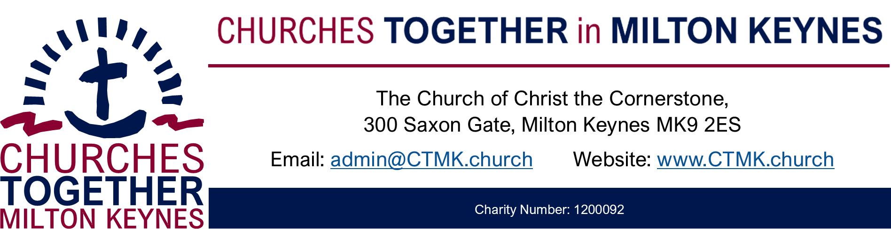

Churches Together in Milton Keynes
Membership Covenant

Congregation: …………….……………………………………………

As a member of Churches Together in Milton Keynes, we will work with other Christian congregations in this area to:
- Show God’s love to the Borough and City of Milton Keynes
- Support each other as followers of Christ

We pledge a gift of …….…. each year to fund the work of Churches Together in Milton Keynes Trust for the next …..…... year(s).

We will ensure that there is a named person for communication with Churches Together in Milton Keynes and other member churches.

This covenant will be reviewed in ………….

Signed on behalf of ……………

Date: ……………….

